**Pre-requisite:**

1. Navigate to Tricentis support portal  
   <https://support-hub.tricentis.com/>
2. Register using Organization email (Kanini/Deloitte)
3. Verify the registered email

**Activate Tosca trial license**

1. Login to tosca support portal

<https://support-hub.tricentis.com/>

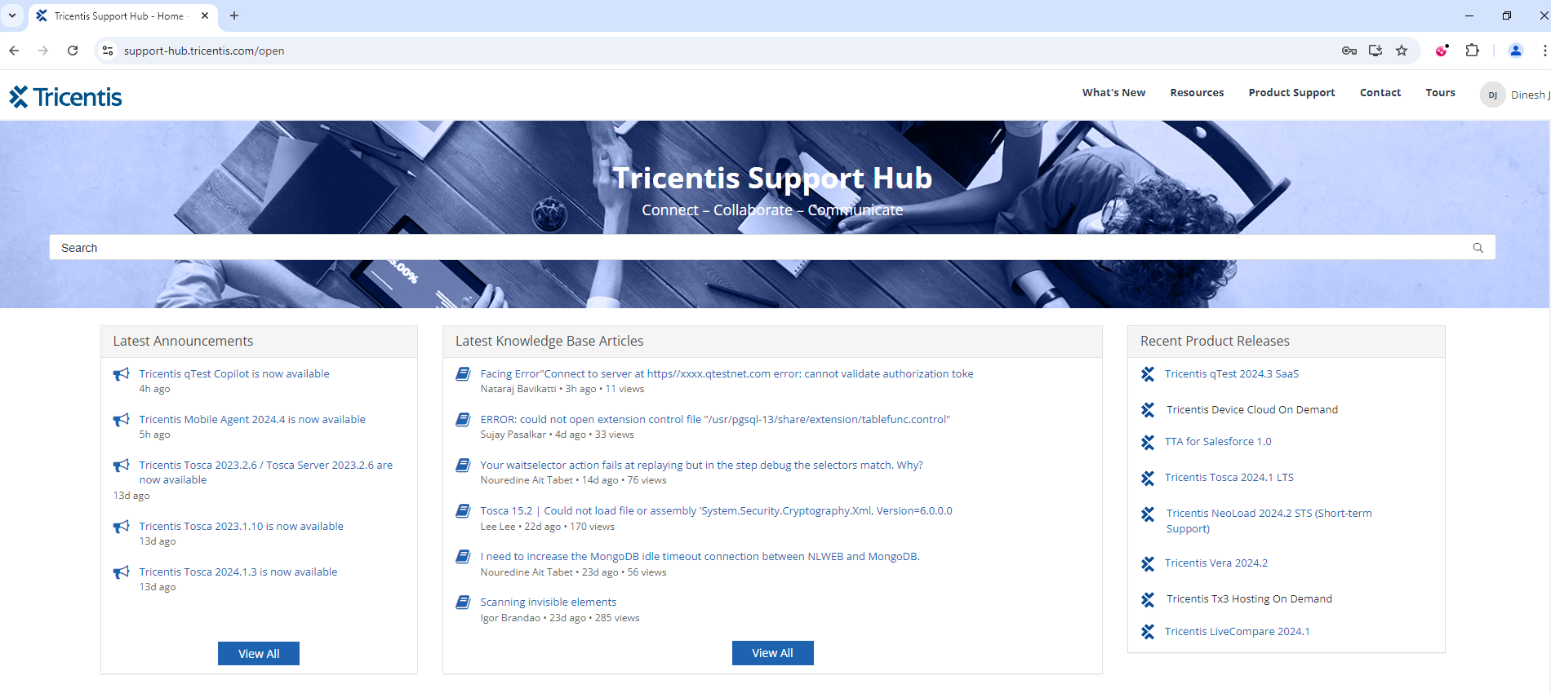

1. In new tab navigate to the below URL

<https://support-hub.tricentis.com/open?id=training_license_request>

* Click on Request cloud training license option
* Verify trial license email received in your Inbox
* Verify Cloud license deployed status

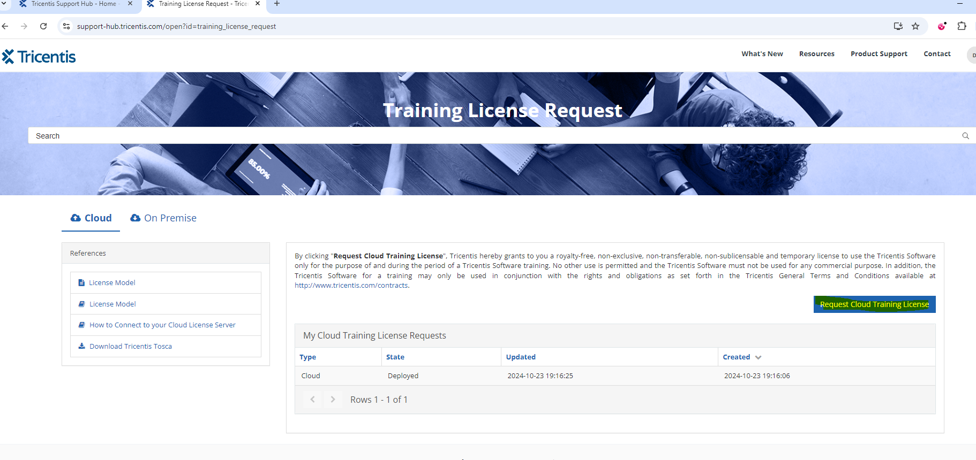

1. Open Tosca License configuration

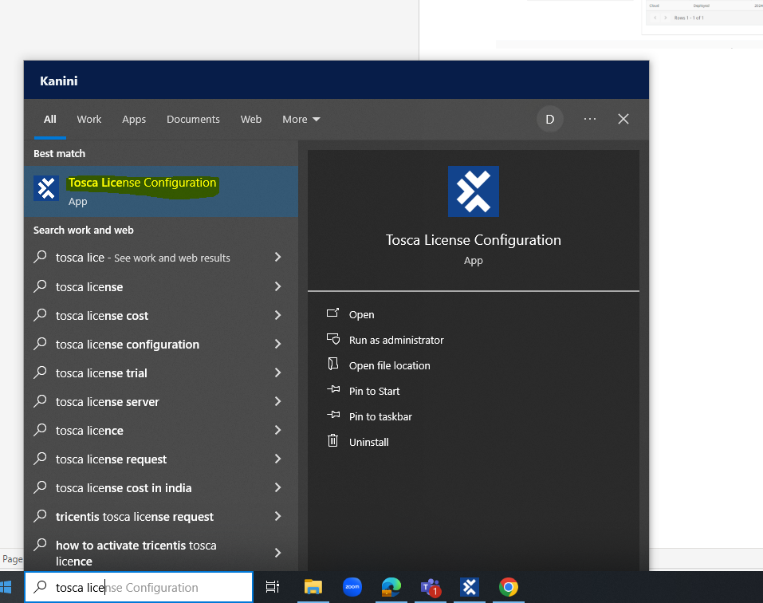

1. Click on Change connection

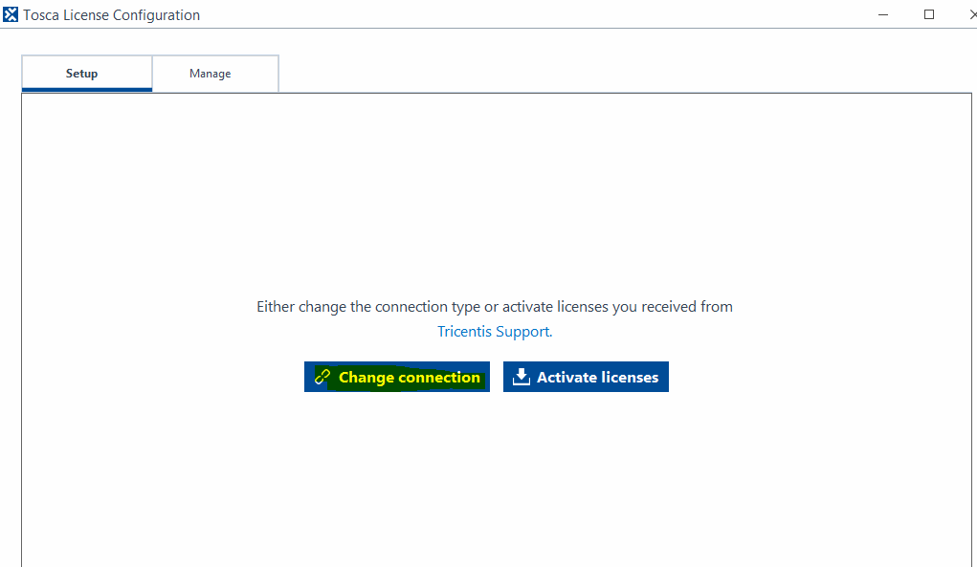

1. Select Cloud hosted license server

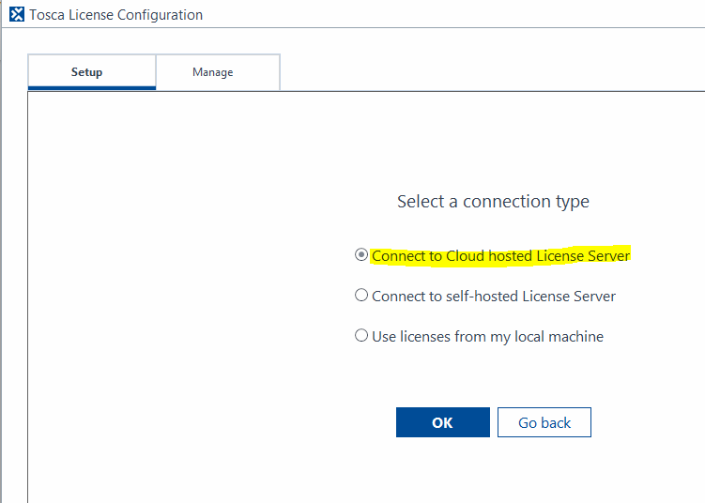

1. Enter Tricentis portal credentials and click on OK

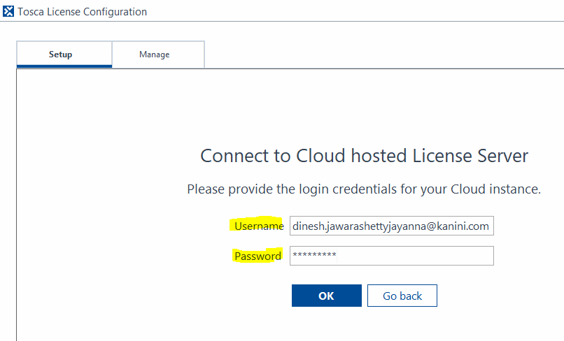

1. Trial license connected

